
OSTIM TECHNICAL UNIVERSITY

FACULTY OF ENGINEERING

ELECTRICAL AND ELECTRONICS ENGINEERING

EEE308 - MICROPROCESSORS TERM PROJECT REPORT

Smart Automation System

Taylan İlyasoğlu - 230202050
Talha Atak – 220202403

May 2026

Introduction and Project Objective
This project presents the design, simulation, and implementation of an integrated "Smart Automation System" that monitors environmental conditions such as temperature, lighting, and security, and automatically controls peripheral devices to maintain optimal room status. The system is built on an Arduino UNO architecture, processing data from an LM35 temperature sensor, an LDR (Light Dependent Resistor), and a PIR motion sensor to manage a DC fan, LED lighting, and warning systems (buzzer). Additionally, the system utilizes an I2C-based 16x2 LCD screen for user interface management and a 4x4 Matrix Keypad for authorization and password operations. By integrating a Real-Time Clock (RTC) and EEPROM memory management, the system achieves a stable architecture that prevents data loss even during power outages.

Hardware Selection
The fundamental hardware components used in the project and their purposes are as follows:
- Microcontroller: Arduino UNO (ATmega328P-based, the main control unit of the system).
- Sensors: LM35 (Ambient temperature measurement), LDR (Ambient light level detection).
- Time & Storage: DS1307 RTC Module (Real-time clock and date data), Internal EEPROM (Non-volatile storage for user passwords).
- User Interface: 16x2 Character LCD (with PCF8574 I2C module for pin optimization) and 4x4 Matrix Keypad.
- Actuators & Indicators: DC Motor/Fan (driven by a 2N2222 transistor), Red/Green/White LEDs, and an Active Buzzer.

System Architecture and Pin Configuration
The circuit design was implemented in the Proteus environment, optimizing the pin distribution between analog sensors and digital control interfaces.
- LM35 Temperature Sensor: A0
- LDR Light Sensor: A1
- White LED (Lighting): A2
- PIR / Motion Detection: D9
- Buzzer, Red LED, Green LED, Fan: D10, D11, D12, D13 respectively
- Keypad: Rows (D2, D3, D4, D5), Columns (D6, D7, D8, A3)
- I2C Bus (LCD and RTC): A4 (SDA), A5 (SCL)
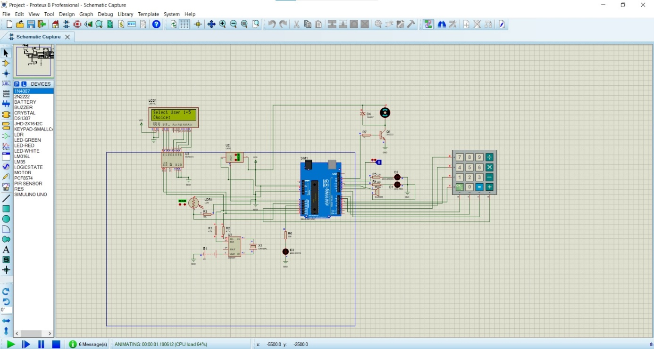
Figure 1: Circuit Schematic

Software Design and Algorithms
The software architecture was designed using a "State Machine" approach (enum ScreenState) to effectively manage complex menu structures. This ensures seamless transitions between the main menu, temperature menu, light menu, and user login screens without conflicts. In the security layer, user passwords are saved to the microcontroller's EEPROM memory, ensuring that authorized user data (e.g., the admin password) is preserved even when the device is rebooted.

Simulation Results
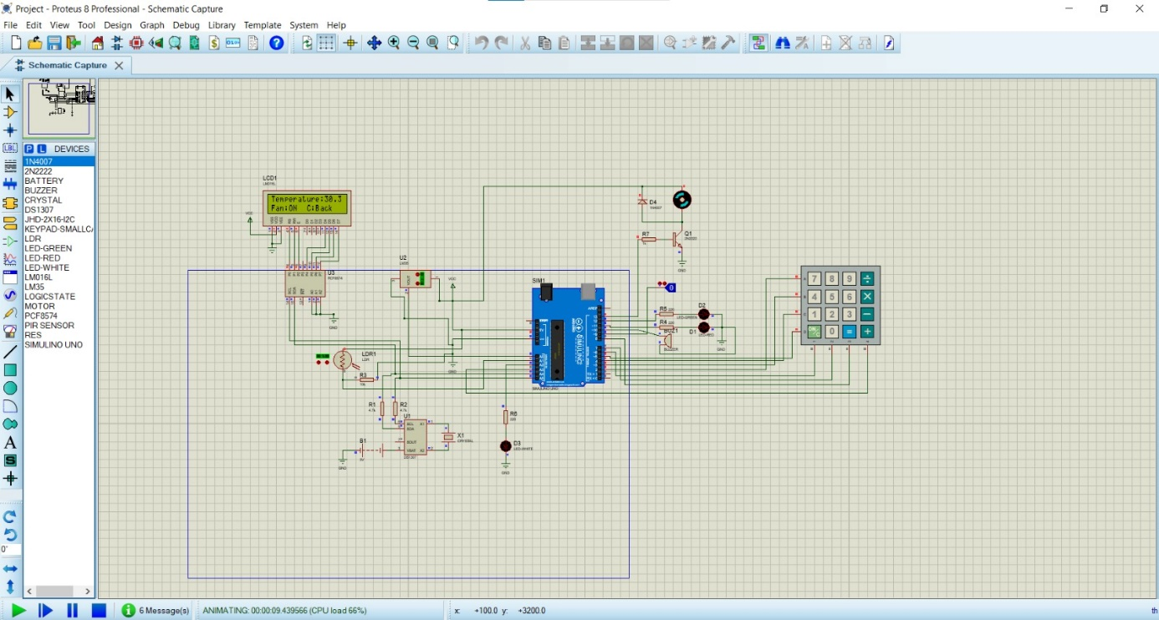
Figure 2: When the LM35 sensor registers an ambient temperature of 30°C, crossing the predefined threshold, the system autonomously switches the Fan to the ON state to regulate the environment.
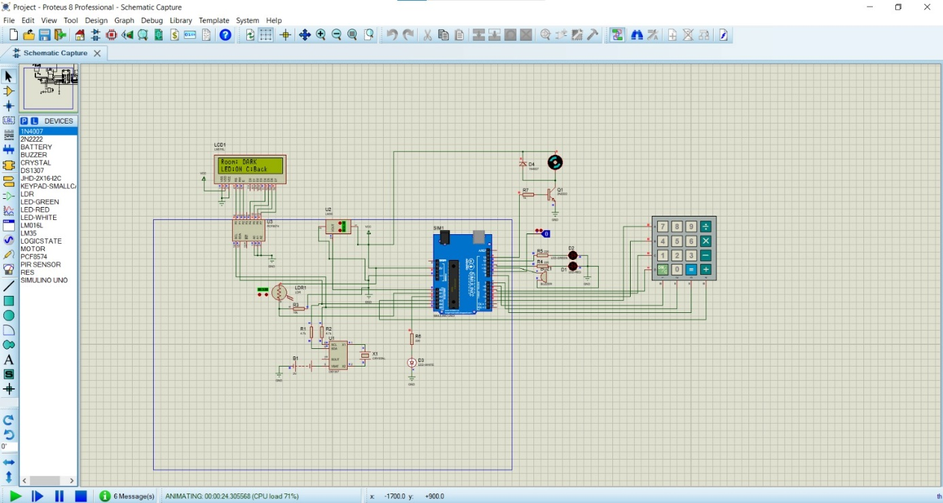
Figure 3: The LDR detects a drop in ambient light, classifying the room as DARK. In response, the system activates the white LED for illumination.
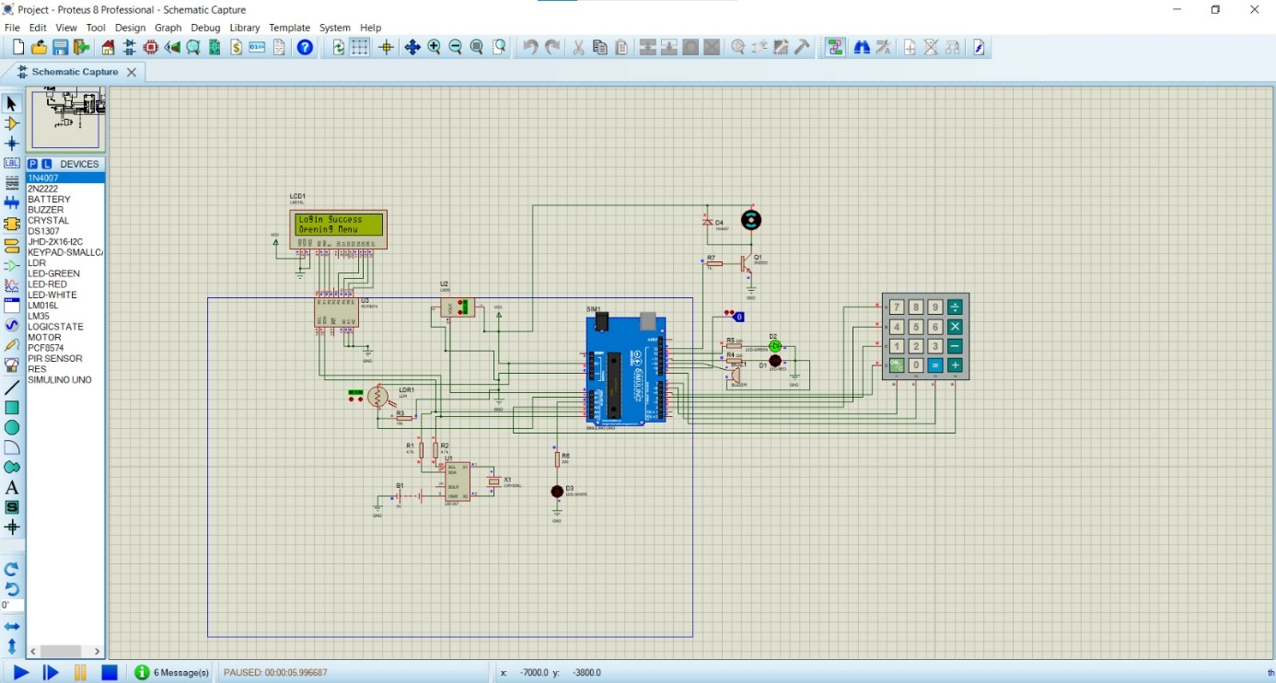
Figure 4: Upon entering the correct PIN sequence, the system verifies the EEPROM record and grants access, displaying a "Login Success" message.

Hardware Implementation Challenges and Troubleshooting
- I2C Communication and RTC Module Issue: In the Proteus simulation, using 4.7kΩ pull-up resistors on the I2C data lines (SDA/SCL) or the DS1307 RTC module outputs was required for stable system operation. However, when transitioning to the real physical circuit, the system failed to read the I2C bus with these resistors attached, resulting in an "RTC Error" message on the LCD. Through systematic troubleshooting, the external pull-up resistors were removed and the RTC module was connected directly to the Arduino, which successfully restored I2C communication.
- Oscillator Failure: Although the communication issue was resolved, the physical DS1307 module exhibited a hardware fault. The crystal oscillator on the module was defective, causing the clock value to freeze and display a static time on the LCD screen. This hardware malfunction was noted in the laboratory findings, and temporary software timers were utilized as a fallback mechanism.

Task Distribution
- Talha Atak: Executed the Proteus circuit design, completed the hardware integration of the sensors, and coded the EEPROM-based password management system.
- Taylan İlyasoğlu: Developed the "State Machine" menu architecture on the LCD screen, implemented the Keypad integration and coding, and wrote the project report according to academic standards.

Conclusion
This project successfully designed the hardware and software infrastructure of a smart automation system capable of analyzing environmental factors, making autonomous decisions, and ensuring user security. Both the simulation and real-world implementation phases provided in-depth practical experience in embedded system response times, the hardware sensitivities of the I2C communication protocol, and non-volatile memory (EEPROM) management.

References
[1] Arduino, Arduino Uno Rev3 Datasheet, 2024. [Online]. Available: arduino.cc
[2] Texas Instruments, LM35 Precision Centigrade Temperature Sensors Datasheet, 2017.
[3] Maxim Integrated, DS1307 64 x 8, Serial, I2C Real-Time Clock Datasheet, 2015.
[4] Labcenter Electronics, Proteus Design Suite 8 User Guide, 2024. [Online]. Available: labcenter.co.uk

